ST. FRANCIS OF ASSISI CHURCH
883 Moscow Street
Munjor, Kansas

St. Francis of Assisi – Munjor School Guidelines
Munjor School ~ 892 Main Street

July – 2022 (Addendum October 2022)

A. FUNCTION - RESPONSIBILITIES

As part of St. Francis of Assisi Church’s mission to offer hospitality and social needs, the Munjor School can be used by parishioners, responsible individuals, and organizations. However, the parish reserves the right to deny or cancel usage if the individual or group intends to use it for the purpose to promote or support any activity that is in contradiction to the basic tenants of the Catholic faith.

A thorough understanding of responsibilities by the requesting person(s) or organization
shall be acknowledged by the signature of that person on the "Rental Agreement Form."

B. PRIORITIES OF USE

- Parish Functions are the first priority, such as Parish Meetings, Gatherings, Religious Education, Funerals, Christian Mother Functions, and other parish sponsored fellowship.
- Parish member functions are the second priority, such as wedding, anniversary, baptism, First Communion celebrations etc.
- Non-church parish member activities are third priority, e.g., shower, family reunion etc.
- Non-Parishioner events are last priority e.g., sport practices, civic or public meetings. Bookings may be subject to cancellation in the event an unexpected parish need arises.

C. FEES

All bookings for the Munjor School must be made with Lilly Binder, Pastoral Associate.
(785-623-8000)

Rental Fees Parishioner Non-Tithing Parishioner
Non-Parishioner

Dining Room (full day) $150.00
Dining Room (½ day) $100.00

Kitchen $100.00

Gym (when using the kitchen & dining - no tables/chairs) No additional charge.
Gym (no tables/chairs – basketball etc.) $40.00/hour
Gym (with tables & chairs) (full day) $350.00 + $175 Security $700.00 plus $350 Security
Gym (with tables & chairs) (½ day) $200.00 + $100 Security $400.00 plus $200 Security

Funerals $100.00 $100.00

Unless stated, use by tithing Parishioners of St. Francis - No Charge. Donation appreciated.

Fifty percent of the Room(s) rental fee is due at time of booking. The entire Security Deposit is due thirty days prior to the event. The remaining balance for the rental fee is due 1 week prior to the event.

Building Access
For events requiring decorating etc., renters will have access at 8:00 a.m. day prior to event and must vacate the building by noon the day following event. (i.e., 8 a.m. Friday, Saturday, Noon on Sunday). $100 additional fee for each additional day.

Cancellations
Security deposit not refunded. Re-scheduling permitted; ½ fee and security deposit honored.

Paper goods (plates, cups, trash bags etc.) to be provided by requesting party.

D. RESPONSIBILITIES

- The requesting party will assume full responsibility for the use and final condition of the facility. Before leaving:
  - Floors are to be swept (also, wet-mopped if needed)
  - Tables/counters cleaned.
  - Restrooms checked.
  - Lights turned off.
  - All trash is to be picked up inside and outside the building and placed in the parish dumpster, located on the West side of church.
- Renters are responsible for setting up and taking down tables and chairs.
- Children are not allowed in the building unless an adult is physically and responsibly present.
- There will be NO SMOKING in the facility (including restrooms) at any time.
- The exit doors must be kept unlocked and unblocked while using the facility.
- All cooking will be confined to the kitchen only.
- Use of building consists of Kitchen, Dining Area, Gym, and Bathrooms only. No access to the rest of the building.
- Noise levels to be maintained at a reasonable level, as the facility is within residential area.
- Items prohibited on the premises at any time include unauthorized intoxicants, illegal drugs, firearms, fireworks, flammable materials, illegal gambling, animals (except guide/assistance dogs) or media that is inappropriate for a Catholic facility.
- It is asked that the building be cleared by 12 midnight.
- St. Francis of Assisi Church allows the consumption of alcohol on the premises at the facility user’s discretion. HOWEVER, the host of an event is asked to hold the guests in a responsible attitude with drinking in moderation. Alcohol is not to be served past 11:30 p.m.

THE FACILITY USER IS REMINDED OF CRIMINAL LAW OBLIGATIONS:
K.S.A. 41-715 prohibits a person to sell, give away, etc. to another who is already incapacitated. K.S.A. 21-3610 prohibits the sale or furnishing of liquor or beer to a person under 21 years of age, either directly or indirectly. K.S.A. 41-727 prohibits a person under 21, to possess or purchase alcoholic liquor or beer.

E. DECORATING

- Nothing may be placed on the walls that would permanently mar the surface.
- No rice, birdseed, confetti etc. are allowed on the facility property.
- No tape, wax, sawdust, silicone powder etc. to be used on the floors.
- Candles or open flames not allowed. Sterno burners for chafing dishes are allowed, as long as proper precautions are maintained.
- Extension cords must be rated to carry the load for intended use. They are not to be taped to the floor. A rug may be used to cover cords in traffic areas.
- All decorations and personal items are to be removed immediately upon conclusion of the event, unless previously approved by Pastoral Associate.

F. INSURANCE REQUIREMENT

- St. Francis of Assisi Church requires the facility user to provide a homeowner's certificate with evidence of general liability insurance with a minimum of $1,000,000.00 (one million)
naming St. Francis of Assisi Church & the Diocese of Salina as additional insurers.

- Facility user agrees to hold St. Francis of Assisi Church and the Salina Diocese harmless and indemnify St. Francis of Assisi Church and the Salina Diocese for any loss, costs, damages, or liabilities of any nature stemming from the renter’s use of St. Francis of Assisi Church property.

- St. Francis of Assisi Church is not responsible for accidents, injuries, damaged or lost property.

St. Francis of Assisi Munjor School Facility Rental Agreement

Name: Today’s Date:

Address:

Phone: Type of Event:

Date of Event: Time In: Time Out:

Additional Event Usage Notes: _____________________________________________________

Number of People Expected: (Gym Seating Capacity 300 ~ Dining Room Capacity 56)

Area(s) Rented:

Parishioner Non-Tithing Parishioner
Non-Parishioner

Dining Room (full day) $150.00 plus $75 Security
Dining Room (½ day) $100.00 plus $50 Security

Kitchen $100.00 plus $50 Security

Gym (when using the kitchen & dining - no tables/chairs) No additional charge.
Gym (no tables/chairs – basketball etc.) $40.00/hour
Gym (with tables & chairs) (full day) $350.00 + $175 Security $700.00 plus $350 Security
Gym (with tables & chairs) (½ day) $200.00 + $100 Security $400.00 plus $200 Security

Funerals $100.00 $100.00

Fifty percent of the Room(s) rental fee is due at time of signing rental agreement. The entire Security Deposit is due thirty days prior to the event. The remaining balance for the rental fee is due 1 week prior to the event.
Security Deposit will be returned in full or in part after the facility passes follow-up inspection.
Please return this agreement with the Facility Usage/Indemnity Agreement and insurance certificate.

I have read the St. Francis of Assisi Munjor School Facility Guidelines and the Facility Rental Agreement and understand and accept its conditions.

Signature of Renter: Date:

Parish Signature: Date:

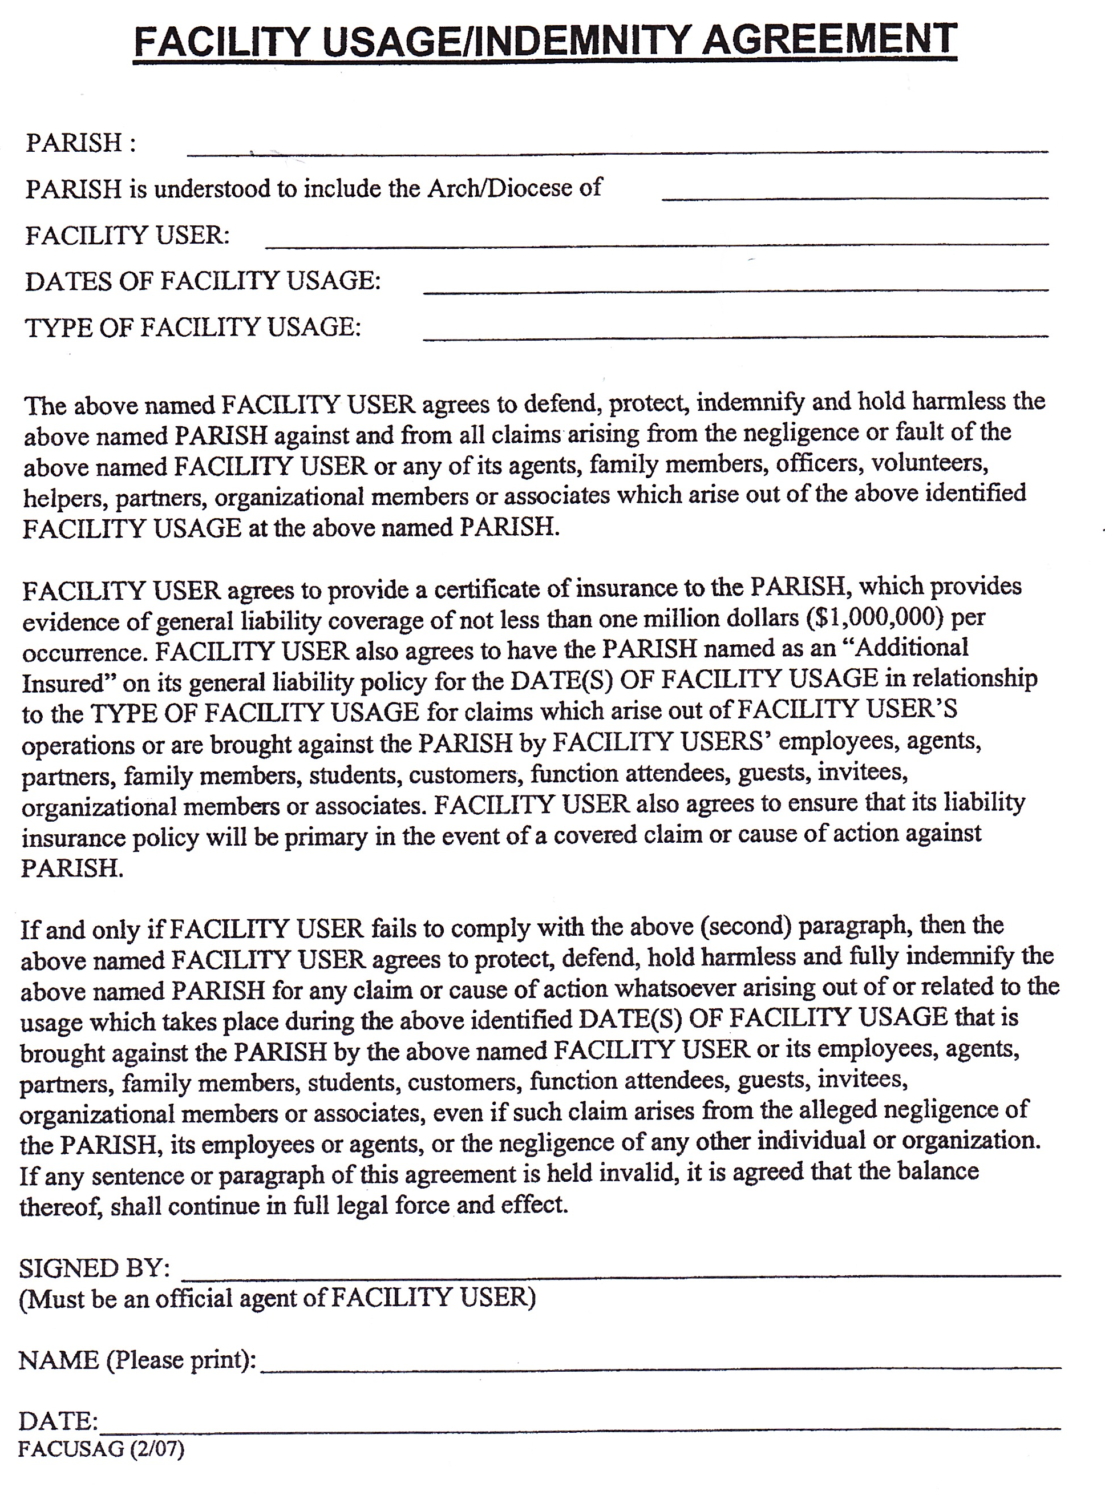

Payment Schedule:

Due At Time of Booking:

50% Room Rental:
Check Amount $ Check Number Date:

30 Days Prior to Event:

Security Deposit (100%):
Check Amount $ Check Number Date:

1 Week Prior to Event:

Remaining Room Rental
Check Amount $ Check Number Date:

Insurance Coverage Form Received:
(Date)



YOUR EVENT

Date of Event:

30 Days Prior to Event:
(Date)

1 Week Prior to Event:
(Date)

